**PIERCE MIDDLE SCHOOL**  
PREFERRED ROUTES AND RECOMMENDED CROSSING POINTS

REC

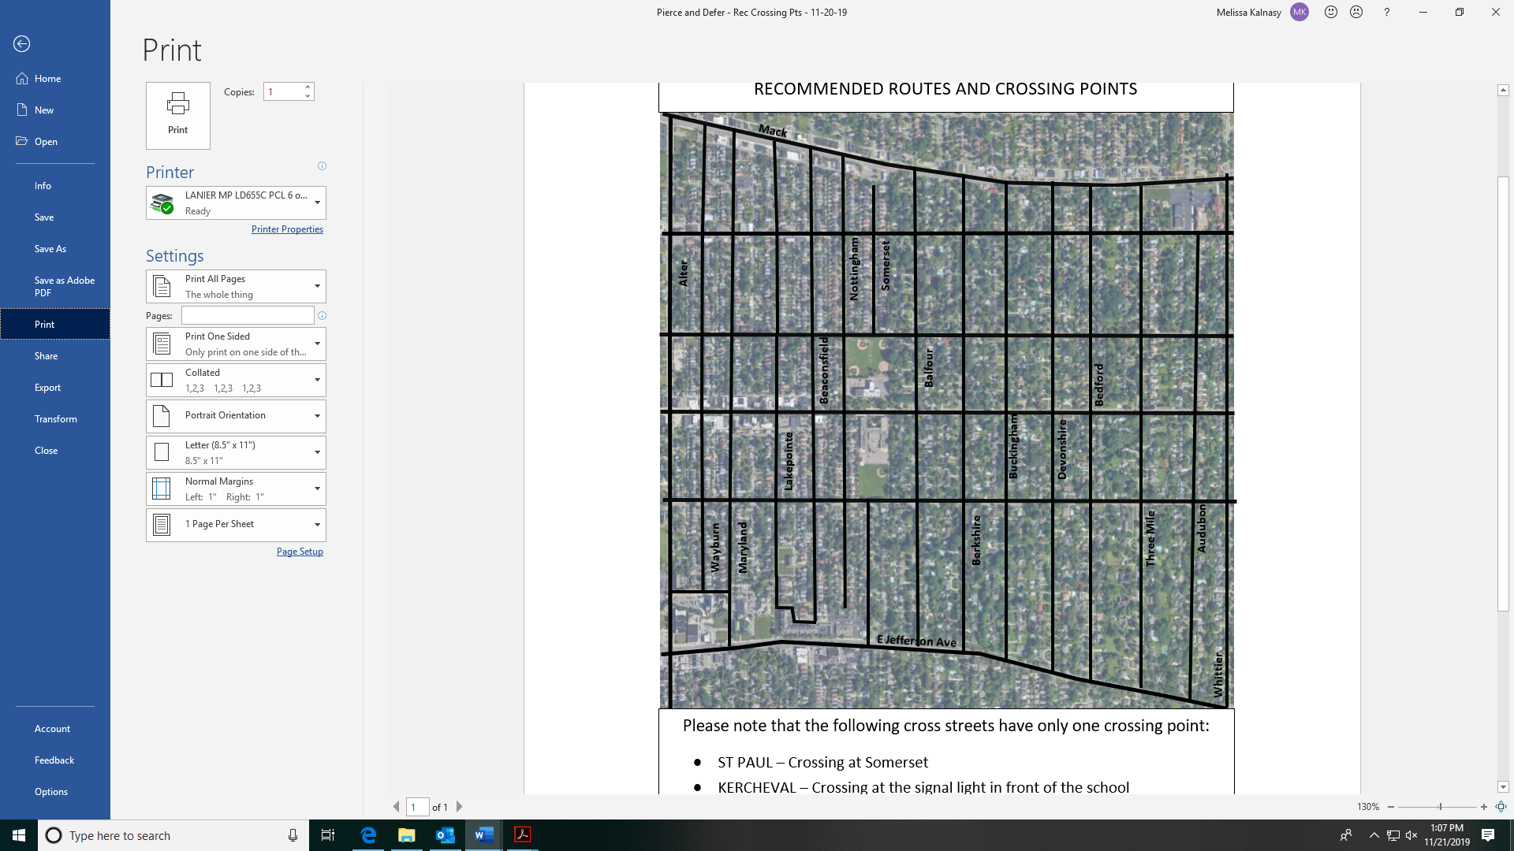

**CHARLEVOIX**

**E VERNOR HWY**

**KERCHEVAL**

**ST PAUL**

**ICON KEY**   
 PREFERRED ROUTES FOR WALKERS   
 AND BIKERS

RECOMMENDED CROSSING   
 LOCATIONS  
  
 PREFERRED ROUTES FOR STUDENTS   
 COMING FROM SOUTH OF JEFFERSON

**PLEASE NOTE** that the following cross streets of St Paul, Kercheval, Vernor, Charlevoix and E Jefferson have only one crossing point. These are as follows:

* ***St Paul:*** Somerset
* ***Kercheval:*** The signal light in front of the school
* ***Vernor:*** The signal intersection at Nottingham
* ***Charlevoix:*** The signal intersection at Nottingham
* ***E Jefferson:*** The crosswalk where E Jefferson, Somerset and Westchester meet. A crossing guard is at this location.

*After-school routes will be reverse of those shown***.**